and GND.

We will finally connect one end of the door lock strike to the positive end of the 4 channel relay and gnd connected to the 12 volt ground of your power supply.

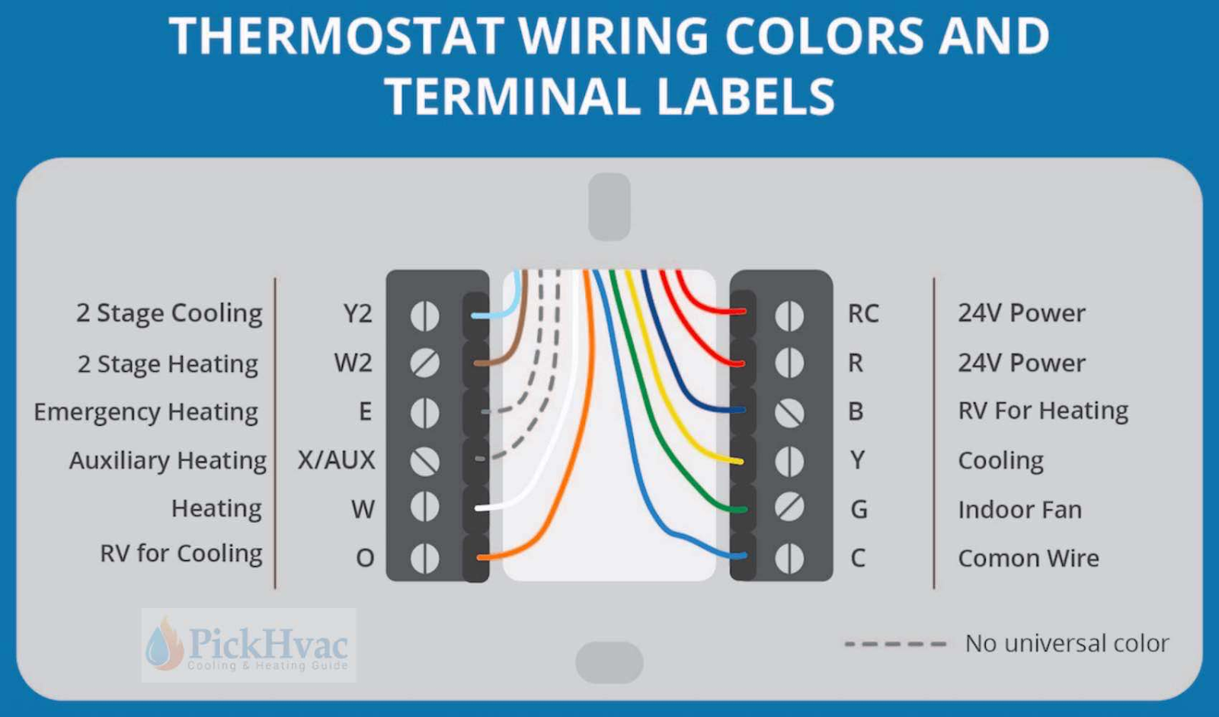

We will follow the standard wiring for the thermostat where the RC wire is attached to all positive sides of the channel relays and the corresponding wire for the cooling heating, and indoor fans are the gnds for each of the relays.

**Installing required programs**

We will have to do a few housekeeping and the best option is to follow established how-to guides for the programs required. So we will look to google to find step by step guides to install the following:

Installing Rasbian

Install mysql

Installing phpmyadmin

Installing python 3 IDL

Installing touch LCD onto Raspberry pi

Getting python code from github (still pending)

Making Raspberry pi visible to using port 8888 (optional)

**To create start up on boot function (OPTIONAL)**

Start by typing sudo nano /home/pi/.bashrc

At bottom of bashrc file type sudo python3 /home/pi/ifttt/iftttpir.py

Function should clear the cmd prompt to start posting if motion is detected after restart.

**Operation of the device**

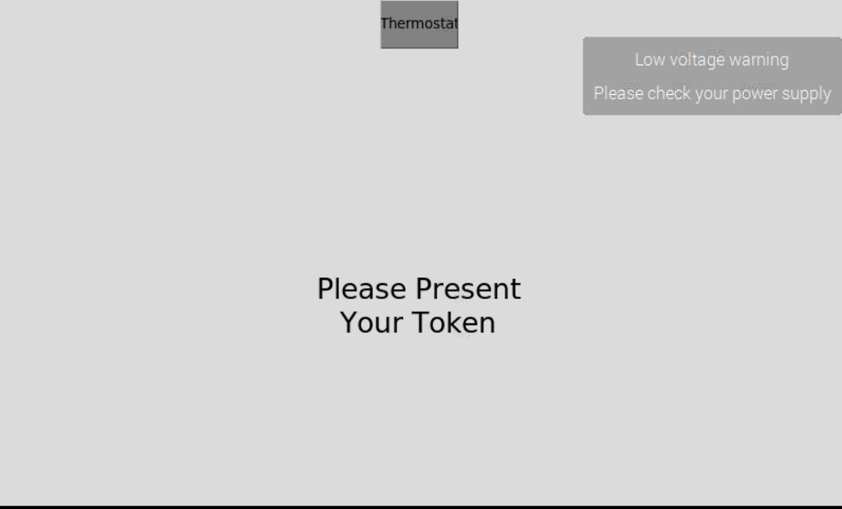

This is the main screen present RFID key to access keypad or click or touch thermostat button to open thermostat\

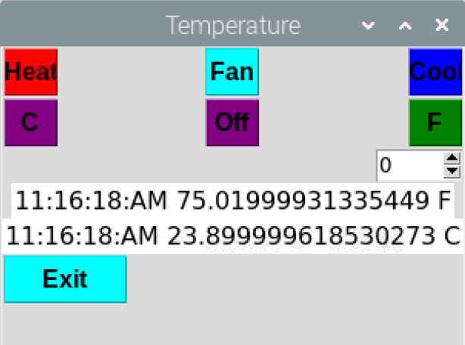

This the thermostat GUI exit takes you back to the home screen the scroll button allows you to increase or decrease desired temperature. Heat, Fan and cool buttons control the requisite functions. The time and current temperature in Celsius and Fahrenheit.

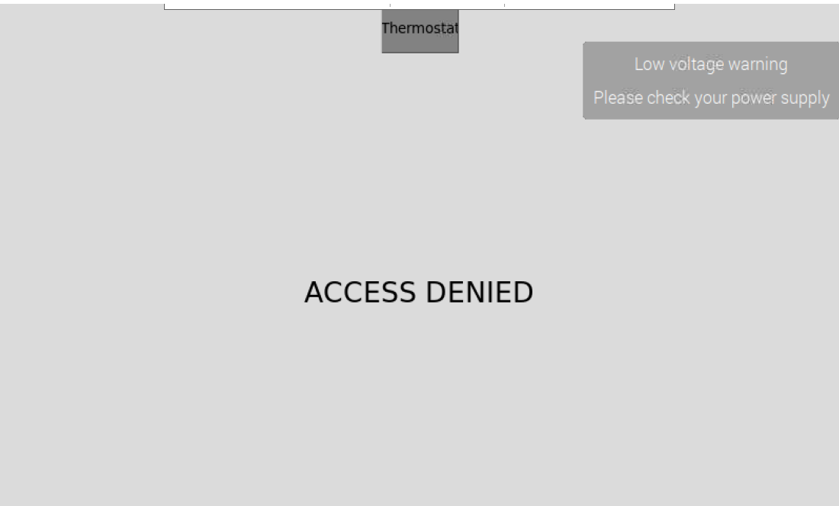

Accessed denied presented when wrong RFID key is presented

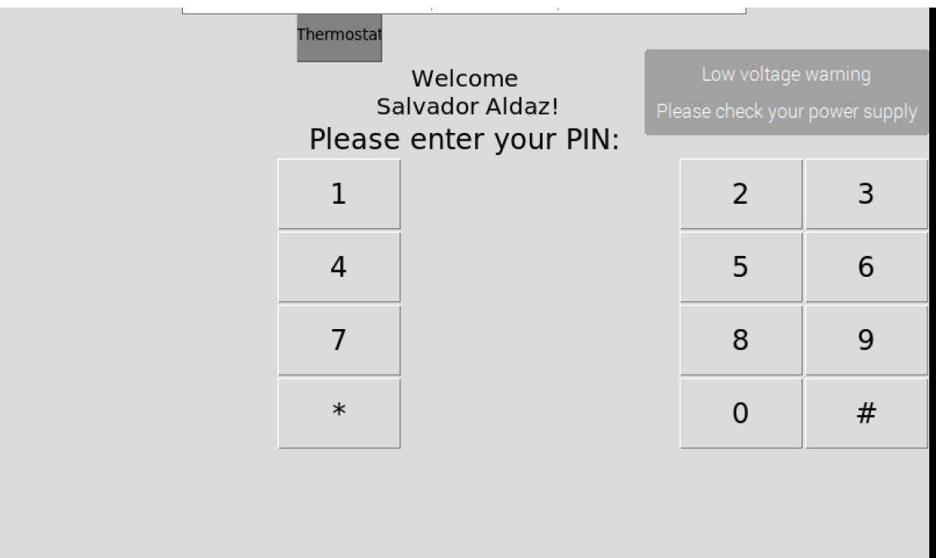

Keypad when the right RFID key is presented is taken back to the home screen if no pin is entered after a time (10 s) .

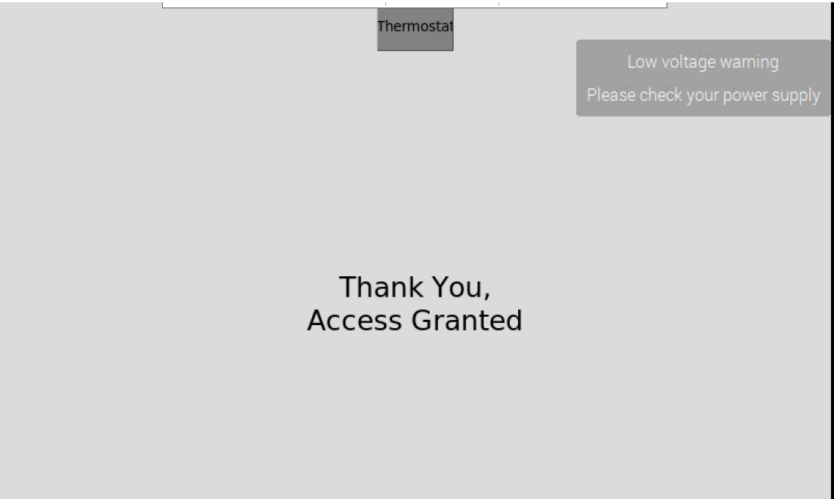

Screen presente when proper pin enter takes back to home screen after a time.

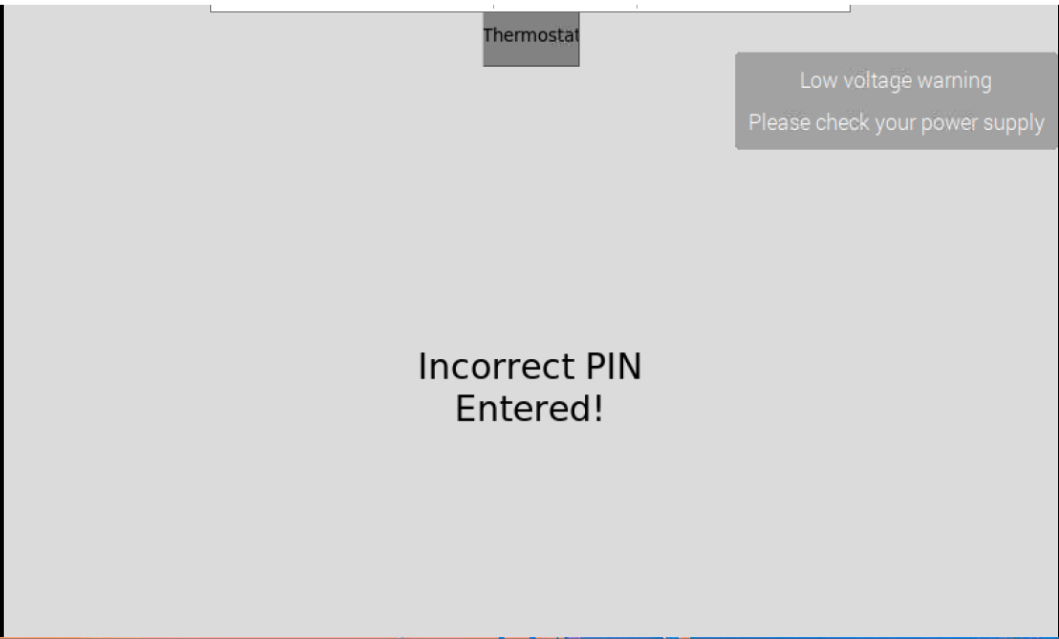

Screen seen when wrong pin presented taking to home screen after a time.

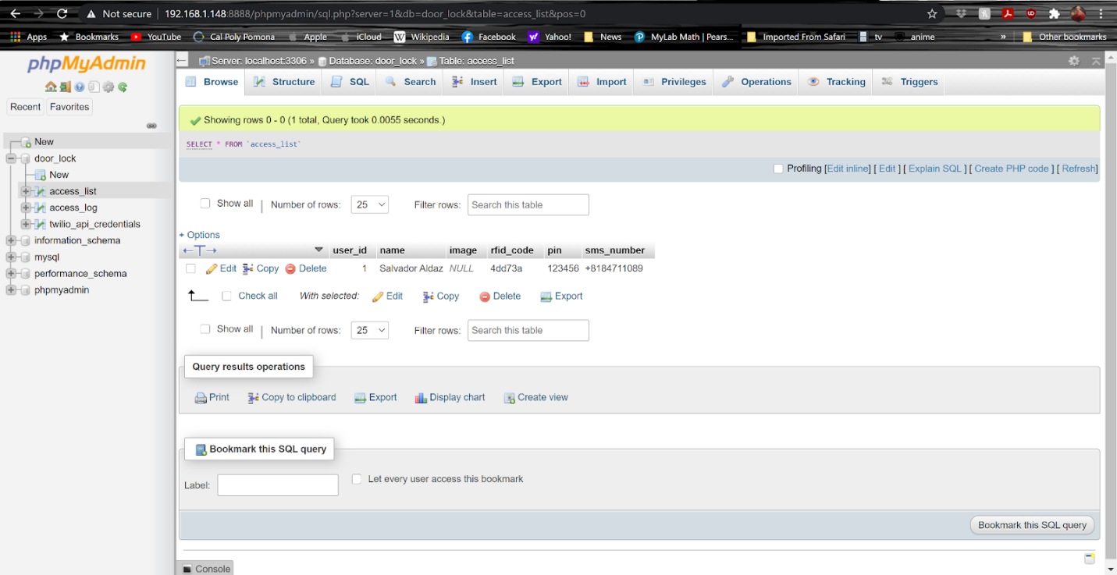

Screen where one can add or remove user with RFID key code

Put in user id, whatever one wants, RFID can be seen from most recent access logs.

Pin can be whatever one wants must be 6 digits long.

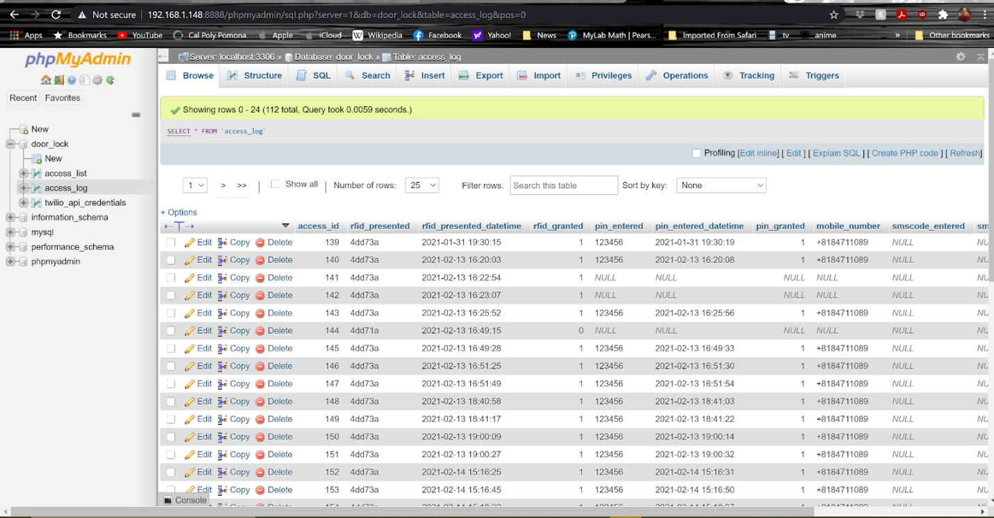

Access log of thermostat and RFID use you see RFID access and the thermostat uses, combined together.